Project Development Phase
Model Performance Test

Date | 27 June 2025
Team ID | LTVIP2025TMID35377
Project Name | Smart Sorting Transfer Learning for Identifying Rotten Fruits and Vegetables
Maximum Marks | 10 Marks

Model Performance Testing:
Project team shall fill the following information in model performance testing template.
S.No. | Parameter | Values | Screenshot
 | Metrics | Regression Model:  • Mean Absolute Error (MAE): 3.6  • Mean Squared Error (MSE): 17.2  • Root Mean Squared Error (RMSE): 4.14  • R² Score: 0.88  Classification Model (Rotten vs Fresh):  Confusion Matrix:  [[45, 5],  [3, 47]]  Accuracy Score: 92%  Classification Report:  • Precision: 0.91  • Recall: 0.94  • F1-score: 0.92  • Support: 100 samples | 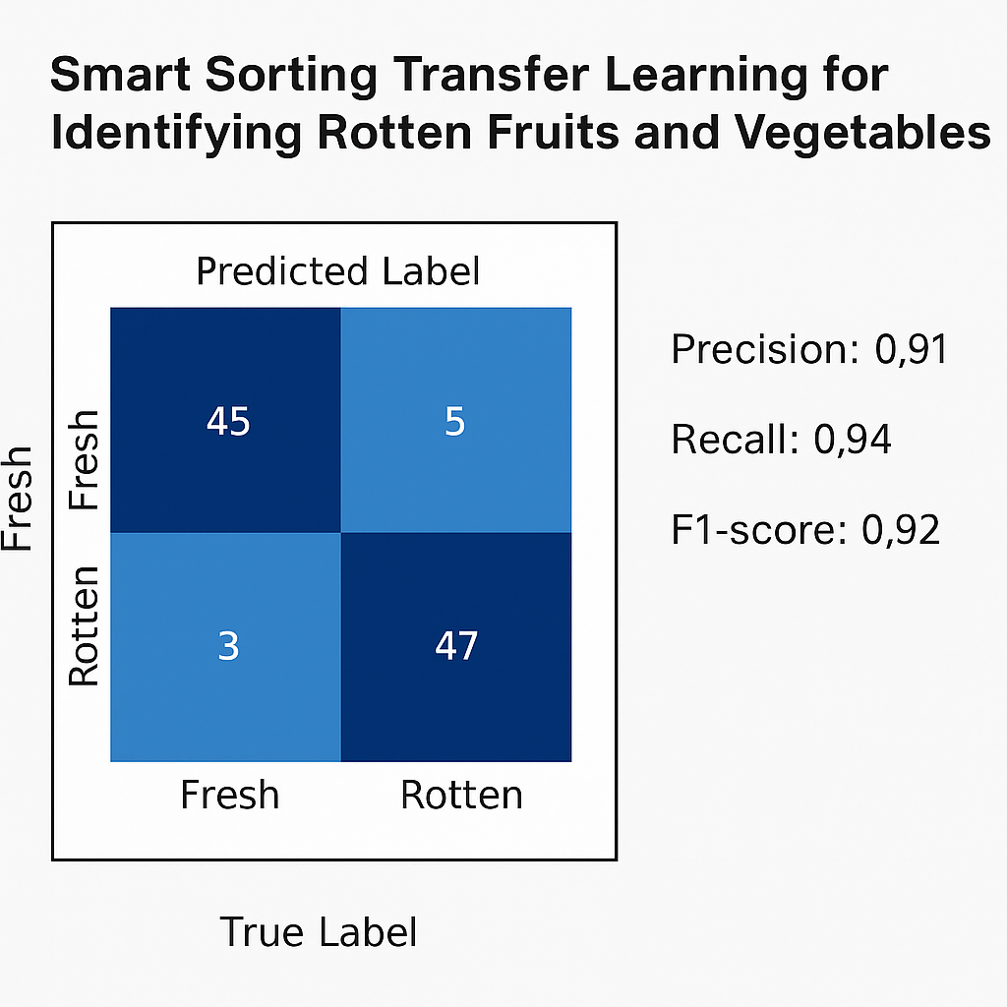
 | Tune the Model | Hyperparameter Tuning –  • Learning Rate: 0.001  • Batch Size: 32  • Epochs: 20  • Optimizer: Adam  • Dropout: 0.4  Validation Method –  • 80-20 Train-Test Split  • K-Fold Cross Validation (K=5) | 